Chapter 1
INTRODUCTION
1.1 File Structures:
A file structure is a combination of representations of data in files and operations for accessing the data. A file structure allows applications to read, write and modify the data. It supports finding the data that might match some search criteria or reading through the data in some particular order. An improvement in the file structure design might make an application work hundreds of times faster. The details of representation of data and the implementation of operations determine the efficiency of the file structure for a particular application.

1.2 Sequential Processing:
The records in a Sequential file are organized serially, one after another, but the records in the file may be ordered or unordered. The serial organization of the file and whether the file is ordered or unordered has a significant baring on how we process the records in the file and what kind of processing we can do.
1.3 Operations:
- Adding new Employee.
- Displaying Employee Details.
- Listing Employees.
- Modify Employee Details.
- Deleting Employee Details.
- Generating Salary Receipt.

1.4 Aim of the File Structure:
- Ideally, we would like to get the information we need once access to the disk
- If it is impossible to get what we need in one access, we want structures that allow us to find the target information with as few accesses as possible.
- We want our file structures to group information so we are likely to get thing we need with only trip to the disk.
1.5 Fundamental Operations on File:
The fundamental file operations are:
Open: A function or system call that makes a file ready for use. It may also bind a logical filename to a physical file. Its arguments include the logical filename, the physical filename and may also include information on how the file is to be accessed.
Syntax: open (filename, flags and mode)
Close: A function or system call that breaks the link between the logical filename and the corresponding physical filename.
Syntax: close (filename)
Create: A function or system call that causes a file to be created on secondary storage and may also binds a logical filename to the file’s physical filename.
Syntax: Create (filename, mode)
Read: A function or a system call used to obtain input from a file or device. When viewed at the lowest level, it requires three arguments: a source file logical name corresponding to an open file; the destination address for the address and the size or amount of data to be read.
Syntax: Read (source file, destination address, and size)
Write: A function or system call used to provide output capabilities. When viewed at the lowest level, it requires three arguments: a destination filename corresponding to an open file; the source address of the bytes that are to be written and the size or amount of data to be written.
Syntax: Write (destination file, source address, and size)
Seek: A function or a system call that sets the read/write pointer to a specified position in a file. Languages that provide seeking functions allow programs to access specific
Syntax: Pos = fseek (destination file, byte offset, origin)

1.6 Services provided to the user:
1. Addition of New Employee: You can find this feature under the public category of class employee. The information contained in this feature are employee code number, name, address, phone number, joining date (day, month and year), designation, grade and loan. Besides these, this function also stores record related to employee’s basic salary, house allowance, and many more.
2. Modify Employee Record: Payroll management system project in C++ asks for employee code from the user for this function to work. Modifications that can be made are the employee code number itself, joining date (day, month and year), name, address, phone number, designation, grade, house allowance and loan given to the employee. Employee’s grade are categorized as A, B, C, D and E.
3. Delete Employee Record: You can simply delete an employee record from Payroll management system project by entering the employee code. A confirmation message is asked stating whether the user really wants to delete the record from the file.
4. Print Employee Salary Slip: This feature too asks for the employee code; the employee code has been used to unlock or perform operations in many features of this payroll management system project in C++. This function lists all the months of the year, and asks for date, employee name, designation and grade from the user.
5. Display an Employee Record: Providing the employee code number, users can access all the provided information related to a particular employee via this function. The employee record information displayed are the ones provided while adding a new employee record.
6. Display List of Employees: Unlike the above function, this feature displays the record of all employees added in file. The records are displayed in a tabular pattern containing information such as code name of the employee, phone number, and date of joining, designation, grade and salary.

Chapter 2
REQUIREMENTS SPECIFICATION

2.1 Functional Requirements:
- The employee details can be displayed from the older entries.
- If the employee is new then with the help of “new employee” module we can enter their details.
- Once the details are entered we can display their information through “List employee” module.
- If an employee details is supposed to be edited, this can be done through the module “Edit employee”.
- If we want to delete an employee from the files then use the module “Delete employee”.
- The main functionality of the project that is generating the salary receipt by considering all the allowances and loan from the agreed salary using the module “salary receipt”.

2.2 Software Requirements:
A system with installed DOSBox and Turbo C++ software and windows operating system.

2.3 Hardware Requirements:
- RAM: 1GB
- HDD: 100GB
- Processor: Intel Pentium

Chapter 3
DESIGN
3.1 Data Flow Design:

Fig 3.1: Data Flow Design
This diagram shows the flow of the data between different Modules and the Files of the Payroll Management System.

3.2 Flow Chart:
Start
New EMP?
Main Menu
Page
New Employee
Yes
No

Delete
Display
List
Salary
Edit

End

Fig 3.2: Flow Chart
This diagram is the flow chart of the Payroll Management System.

Chapter 4
Implementation

4.1 Introduction:
The system is developed with extreme programming practices. This system is developed using the object oriented concepts. The language used is C++.And used the sequential technique with fixed length record. To implement a user friendly and error free system we used step by step correction and implementation of the code.

4.2 Processes involved:
First stage process: The first part of the project involves the processes like sketching of requirements of the project, the possible issues we would face, possible solutions that could be used to overcome them.
Second stage process: In the second stage of the process we decided which language to be used and the user interface to be done. Once the language to be used was decided, we started working on the code based on the requirements considered before. We developed the code function by function testing each module.
We developed the insert, delete, modify, list, display in order and at last integrated all of the functions to see if they worked well together. Any error occurred were looked upon and debugged to reach the requirements. Once the system is error free we gave the users to try the system and took opinion and based on their requirements incremental changes were made. Hence a user friendly and an error free system is developed.

Chapter 5
TESTING

It is integral part of any system’s development life cycle without which the system developed is sure to fail and result in loss of economic and manpower investments besides user’s dissatisfaction and downfall of reputation.

System testing is the stage of implementation, which aims at ensuring that the system works accurately and efficiently before actual operation commences. No program or system design is perfect, communication between the user and the designer is not always complete or clear. All this can result in errors.

Another reason for system testing is its utility as a user oriented vehicle before implementation. The application system is worthless if does not meet user needs, thus the system should be tested to see whether it meets the user requirements.

Testing here is conducted in bottom up approach as follows:
- Unit Testing: Each component is tested independently to ensure that they operate correctly.
- Module Testing: Module encapsulates related components so can be tested without other system modules.
- Subsystem Testing: In this phase the subsystem as a whole is tested along with the detection of interface errors.
- System Testing: The complete system is tested to see if it meets the functional and nonfunctional requirements.
- Acceptance Testing: This is the final stage in the process before the system is accepted for operational use.

5.1 Test Cases:
ID | Module | Test Case Description | Input | Expected  Result | Actual Result | Status
1 | Menu | Enter a valid choice from 1 to 5 or 0 | Press 1 | Opens the New Employee page. | Opens the New Employee page. | Pass
2 | New Employee | Enter Employee details to be stored. | Name: Pk  Address: Bengal  Phone: 9876543210  Date:7  Month:12  Year:1997  Designation: HR  Grade: P  House  Convenes  Loan if:  1000  Basic Salary:10000 | Successfully saved on selecting the option Y | Successfully saved on selecting the option Y | Pass
3 | Display | Displays the details of a particular employee based on employee code. | Employee code:1 | Displays the details of the employee with code 1 | Displays the details of the employee with code 1 | Pass
4 | List  Employee | Displays the details of a list of employees saved. | Select option 3 on the main menu. | Displays all the saved employee details. | Displays all saved employee details. | Pass
ID | Module | Test Case Description | Input | Expected  Result | Actual Result | Status
5 | Salary Receipt | Generates the salary receipt of a particular employee. | Employee code: 1 | Generates the salary receipt of employee by considering all the allowances and deductions. | Generates the salary receipt of employee by considering all the allowances and deductions. | Pass
6 | Edit | Changes or deletes any employee record. | Select option 4 on main menu. | Opens the page to choose modify or delete function. | Opens the page to choose to modify or delete function. | Pass
7 | Delete | Deletes the details of a particular employee based on the selected code. | Employee code: 1 | Deletes the saved details of the employee | Deletes the saved details of the employee | Pass
8 | Modify | Modifies the details of the employee based on the selected code. | Employee code: 1  Re-enter all the credentials and modify if required. | Modifies the saved details of the employee | Modifies the saved details of the employee | Pass
9 | Quit | Quits EDIT module and goes back to the main menu page. | Press 0 | Opens the main menu page. | Opens the main menu page. | Pass
10 | End | Exits from the payroll Management System. | Press 0 | Exits the menu page and the system. | Exits the menu page and the system. | Pass

Chapter 6
Snapshots
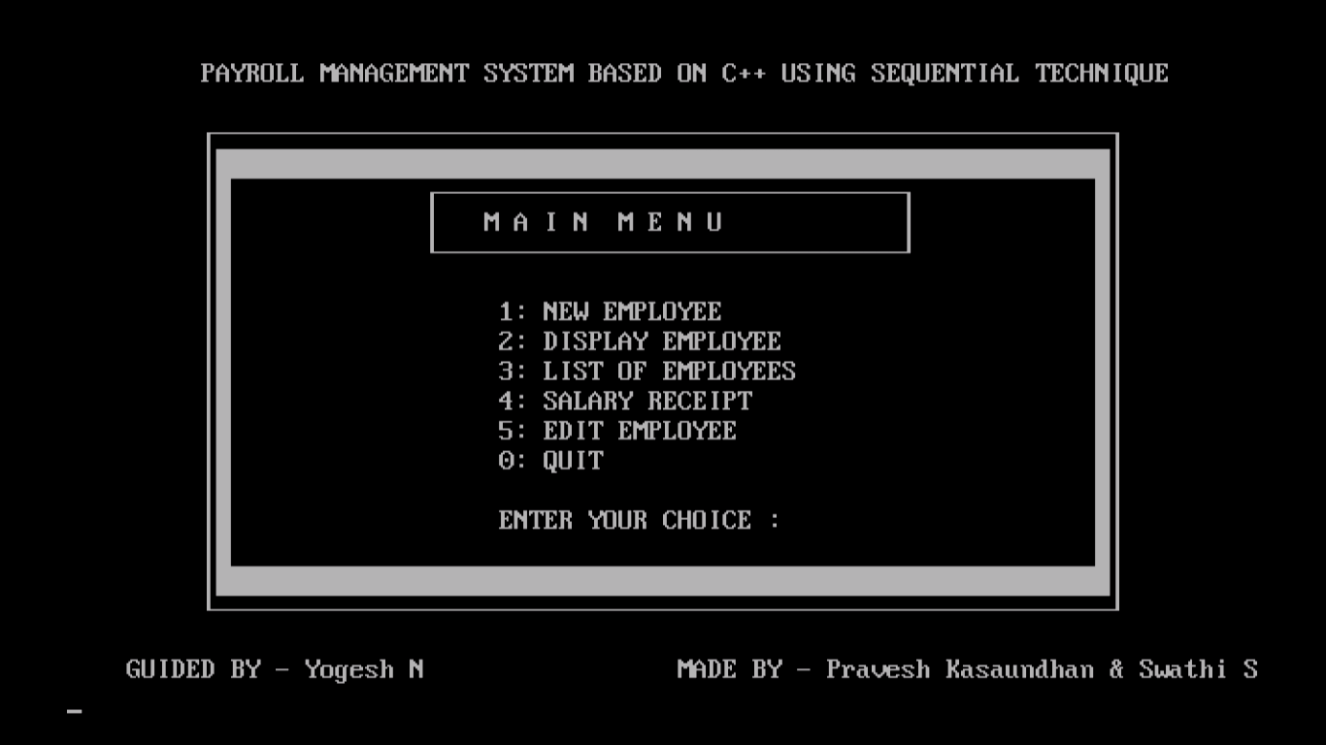
Fig 6.1: Main Menu Page
This is menu page where we can select one of the modules.
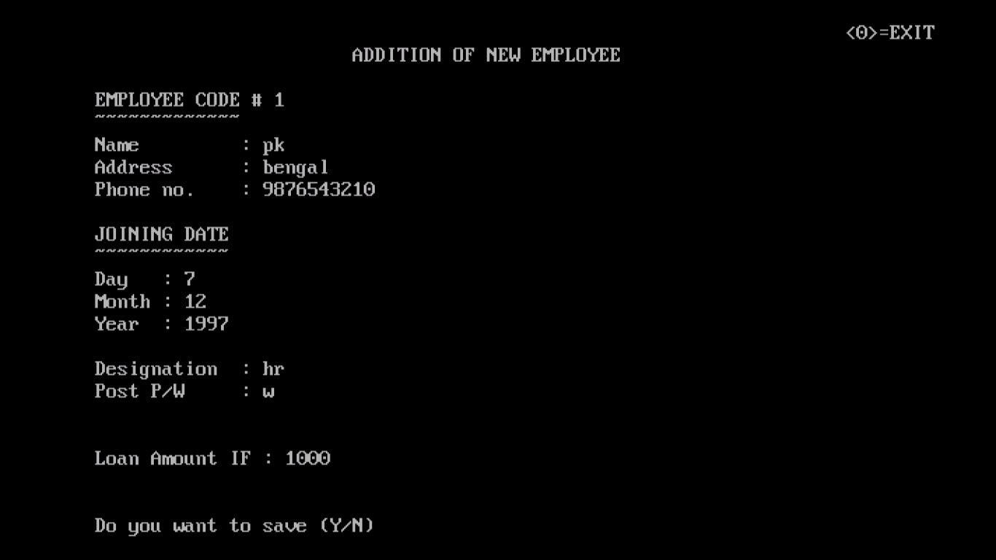
Fig 6.2: Add new Employee
This page lets you add details of new Employee.

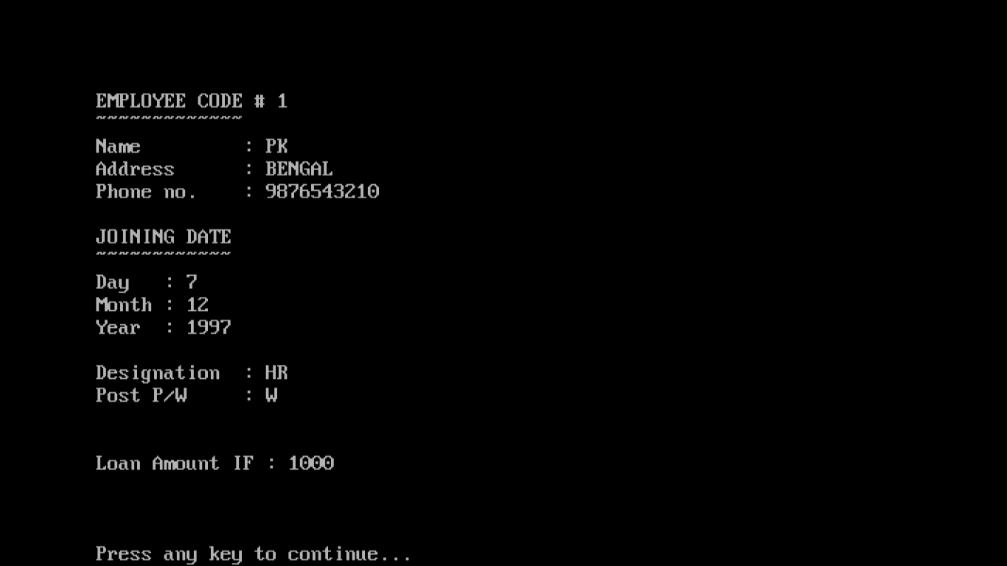
Fig 6.3: Display Employee Detail
This page helps you display the details of particular Employee.

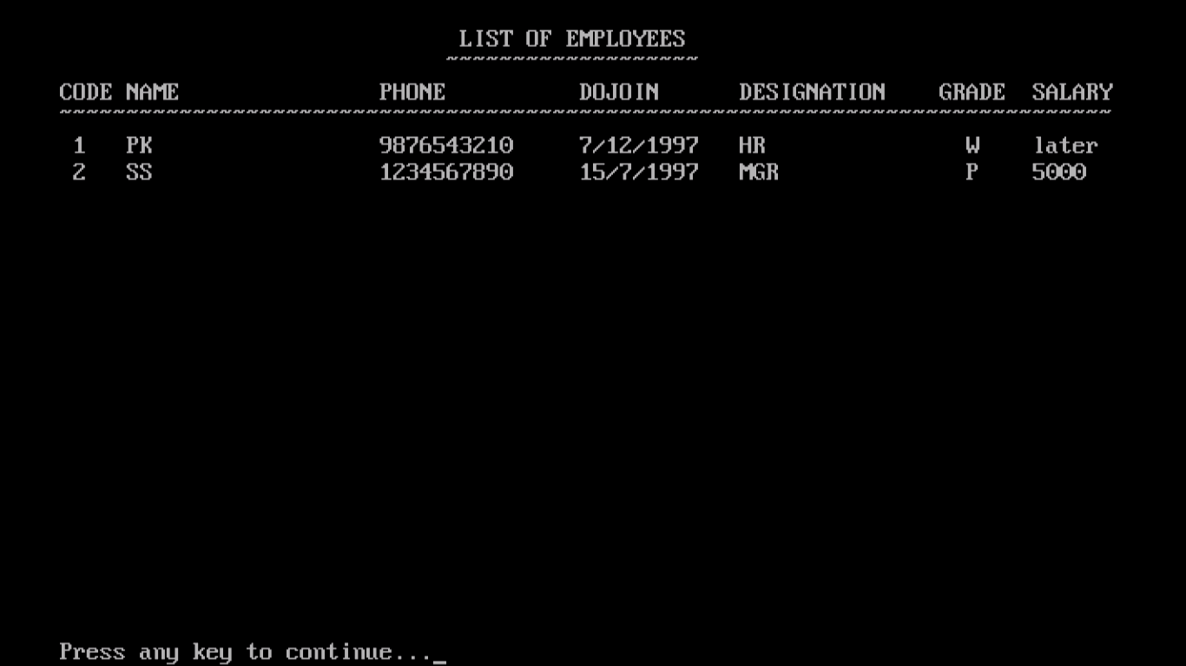
Fig 6.4: Listing Employee Details
This page list the details of all the Employees registered in company.

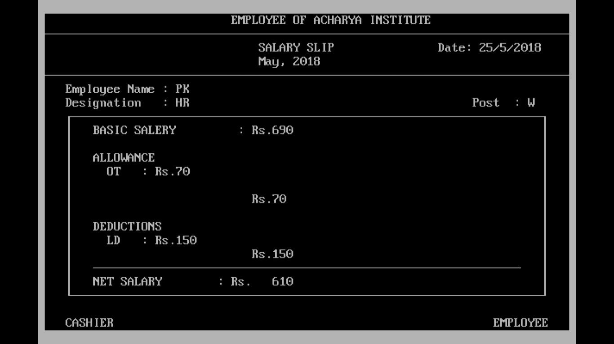
Fig 6.5: Generating Salary Receipt
This is the page which generates the Salary based on the Allowances.

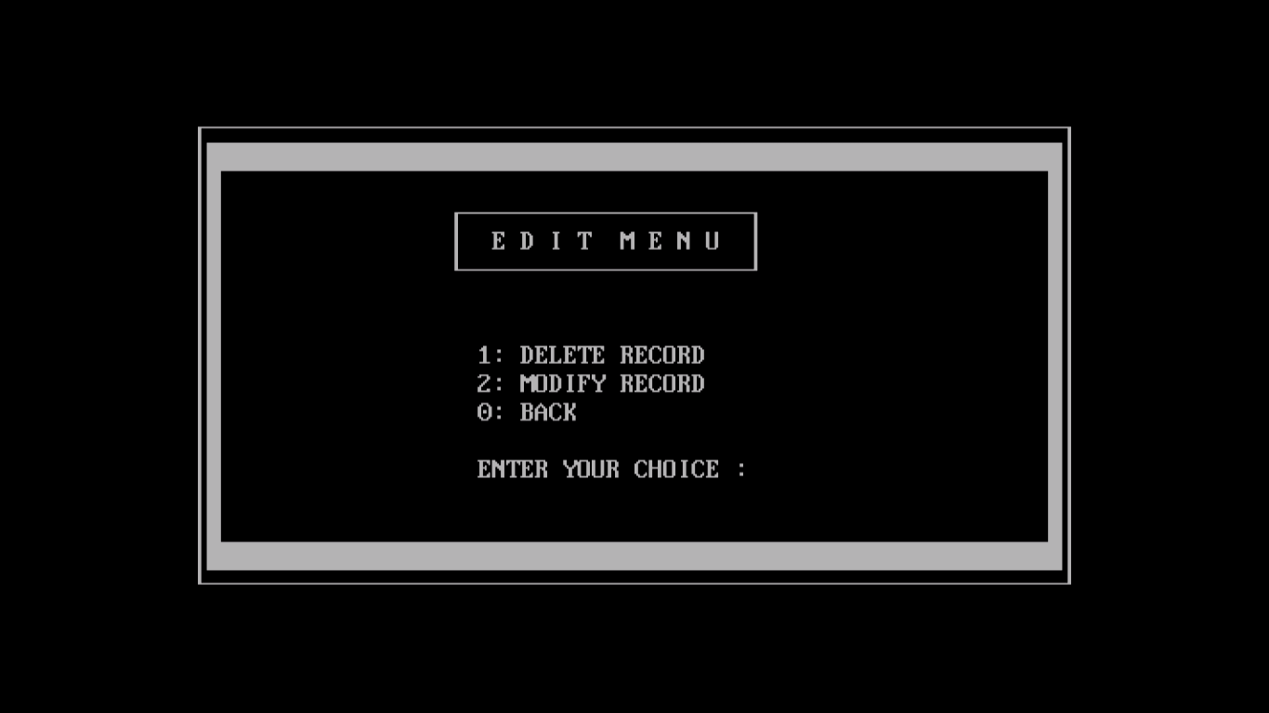
Fig 6.6: Edit Menu
This page lets you select one of the Edit options.

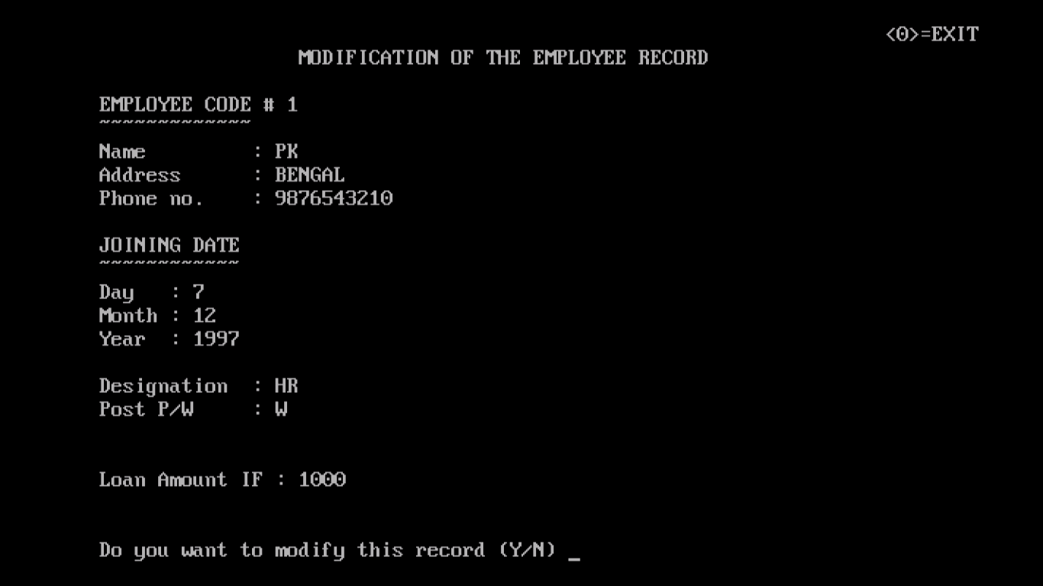
Fig 6.7: Modify Employee Detail
This page helps you modify the details of existing Employee.

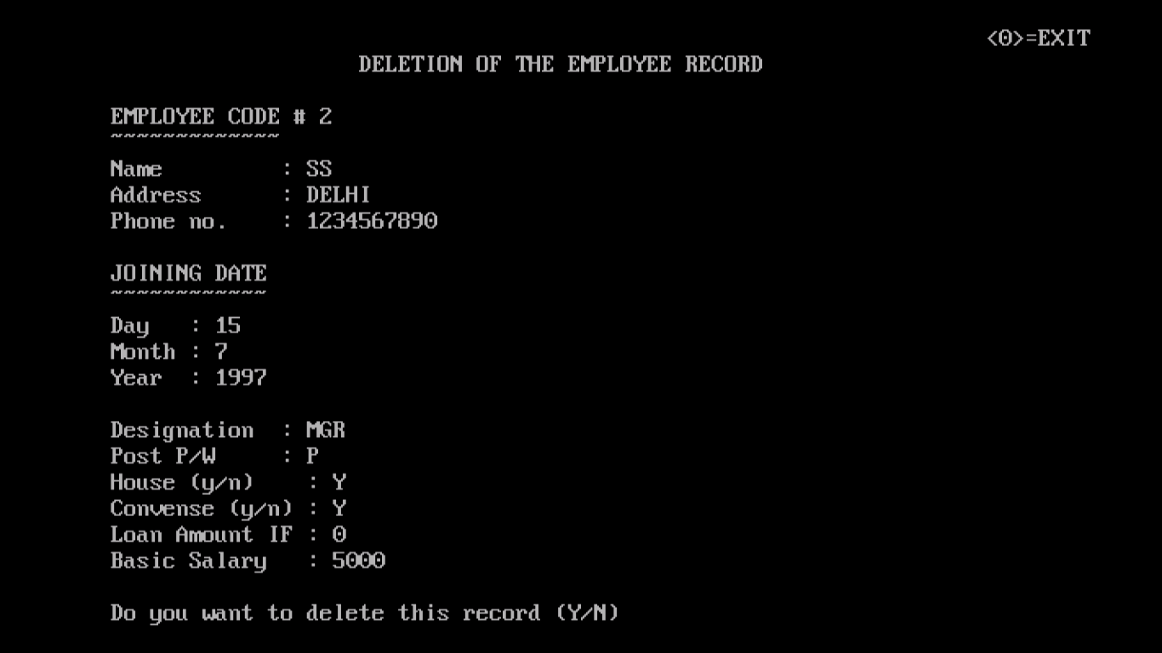
Fig 6.8: Delete Employee Detail
This page lets you delete the record of the existing Employee.
CONCLUSIONS AND FUTURE ENHANCEMENT
Conclusions:
We have used the concept of Sequential Technique on fixed length records in files, which is used to search the files in the system used for maintaining records. These files are loaded into main memory. We search the nth file from N files with N number of searches.
Limitation:
Requires more number of accesses to access a single record. Time Taken is too large. And for every record it requires a key to search. It is limited to the admin only.
Future Enhancements:
Given the File Structure design that we have built, we foresee a lot of areas
That need enhancements.
- Make the system available not only to the admin but also to the valid employees in the read mode.
- Other search techniques like primary indexing, secondary indexing, hashing can be used to make it more efficient.
- We could add other modules like attendance of the employees and tracking their jobs on daily basis.
- The user interface can be made more visual and user friendly rather than the menu driven interface.

BIBILOGRAPHY

Book references:
- File Structures An Object-Oriented Approach with C++ by Michael J.Folk, Bill Zoellick, Greg Riccardi.
- Software Engineering-by Ian Sommerville.

Web references:
- www.stanford.edu
- www.awl.com
- www.codeproject.com
- www.sourceforge.com
- www.w3schools.com

